COGNIFYZ TECHNOLOGIES
Data Science Internship
TASK 2: Price Range Analysis
Intern: Pranav KS
Role: Data Science Intern
Level: Level 2
Observation
Price Range 1 is the most common category, with 4,444 restaurants. The average rating increases across the price ranges, from 2.00 for Price Range 1 to 3.82 for Price Range 4. Price Range 4 has the highest average rating and is represented by the green color in the visualization.

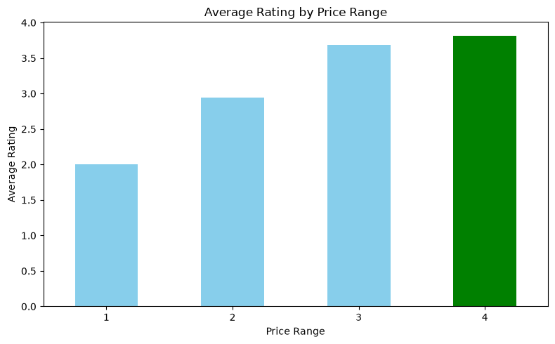

Conclusion

The analysis shows that most restaurants belong to Price Range 1, while Price Range 4 has the highest average rating. This indicates an association between price range and restaurant ratings in the dataset.

